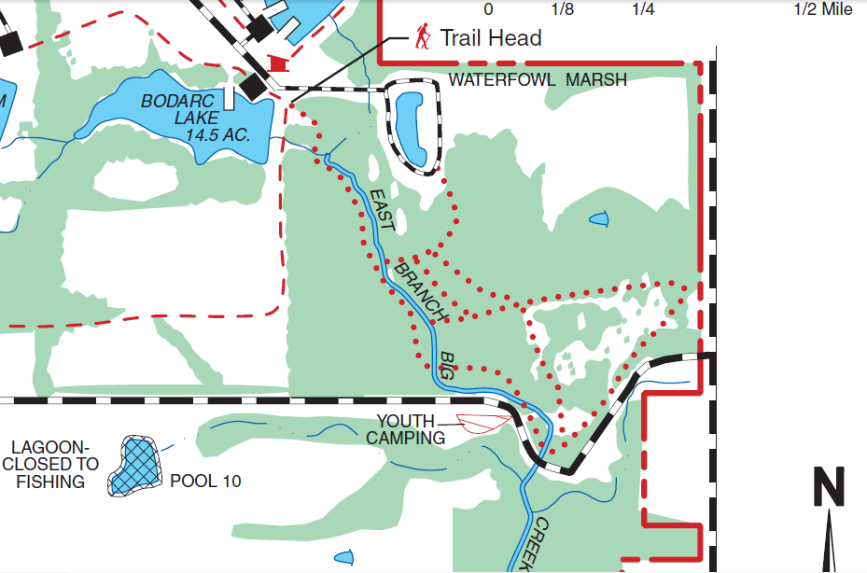

Stay on this trail, always to the right of the river. You will need to go on a dirt trail that starts on the right of the bridge, but do not cross the bridge.

There is another trail that diverts from the trail at the side the river. This trail is wide, like a mowed area, and heads to the road. You will need to walk to the road using this trail, which is marked in purple. Then hike along the road to the youth camping area which is at the curve in the road.

Don’t cross this bridge!