Smithville Bike Plan
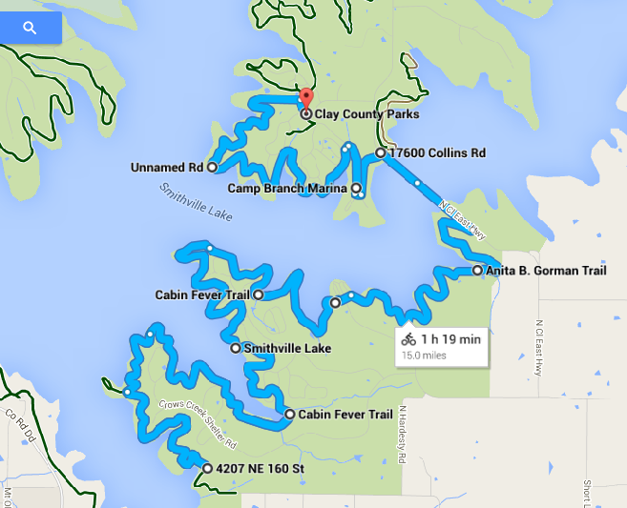
map
N
^
|
W- - E
|
S
Used with a compass, this bike plan completes the 2nd class hike requirement .
start: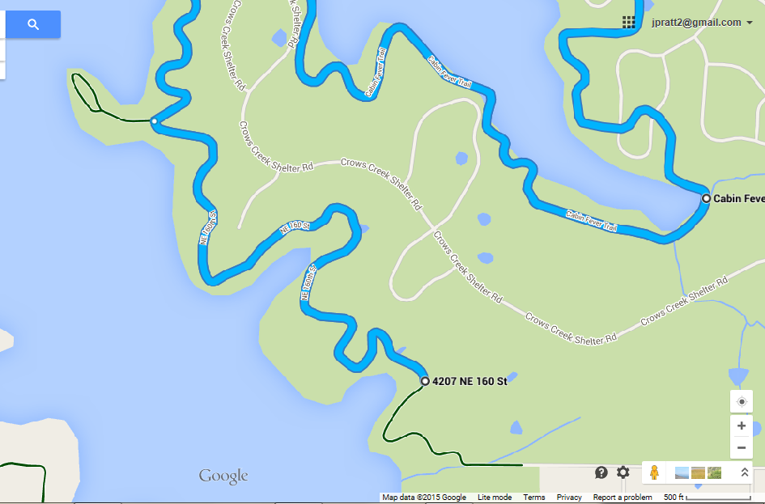
Note the peninsula with a loop, which we could take if we start closer to the bottom loop (driving loop).
End: 15 miles
