Smithville Bike Route, Crow’s Creek Campground, starting point and stopping point are the same
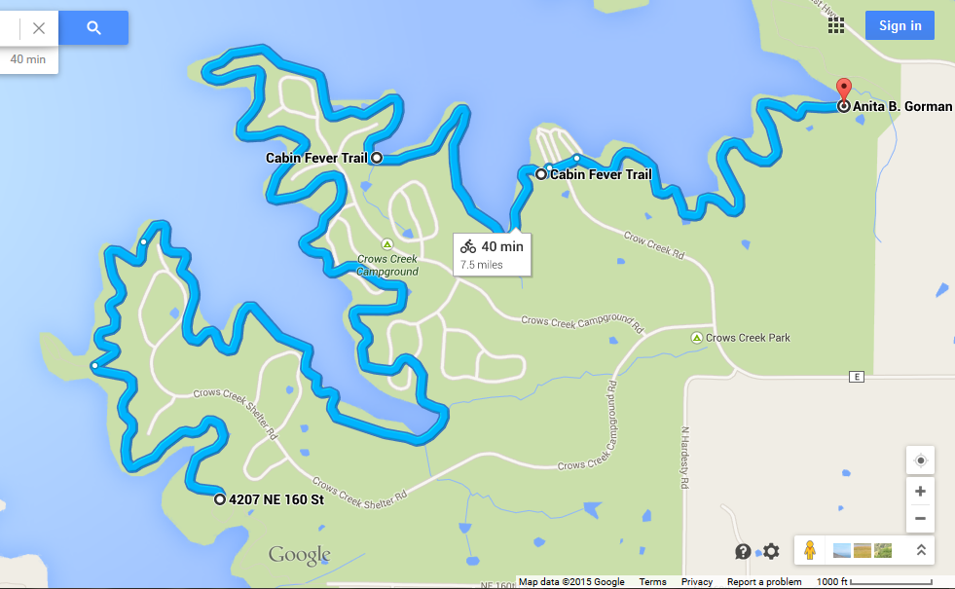
N
|
W- -E
|
S

